CHEM1008
Experiment -Chemical Reactions -Lab 4- Remote delivery
Mark: ___ / 66
Required Readings:
- Read the protocol and complete the lab report.

Required Items
Laptop or tablet, textbook, internet, periodic table, calculator, pencil and eraser.

Purpose
In this experiment, students will be expected to:
- Watch the videos provided and complete the tables.
- Identify the type of reactions that occurred, as required.
- Indicate the measurable evidence that a reaction occurred.
- Balance the reactions and use the activity table and solubility table (as applicable) to predict the outcomes of chemical reactions.

Discussion and Background
Single Displacement reactions demonstrate the ability of an element to replace the ion of another element dissolved into a solution. This experiment will test the validity of the activity (electromotive) series. The activity series provided below shows common metallic elements and ions organized in a descending order of “activity”. Note: for the purpose of the “activity” series, hydrogen is considered a metal. The series was developed in the mining industry to allow efficient extraction of metals dissolved in solutions by forcing the ions to be reduced to metals without the need of an electric current.

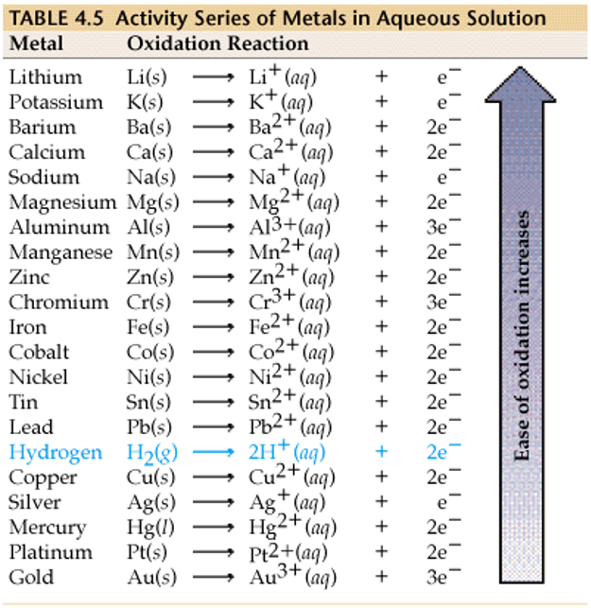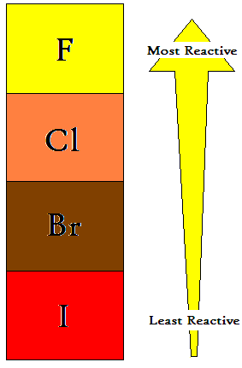

For the general chemical equation: A + CD AD + C

if A is higher in the activity series, it has the ability to ‘replace’ C in the compound with D. This happens if both A and C are metals.

An example of this is: Mg _{(s)} + 2 AgNO_{3 (aq)} 2 Ag _{(s)} + Mg(NO₃)₂ _{(aq)}

When magnesium is placed in a solution of silver nitrate, a single-displacement reaction takes place because magnesium is a more reactive metal (higher on the activity series) than silver.

Metals in the table will lose electrons to the ions of elements below them and become IONS…!
In the case of halogens, if A is higher in the activity series, it has the ability to ‘replace’ the other halogen ‘D’ in the compound to combine with C.

A + CD AD + C
An example of this is:
Cl_{2 (g)} + 2KI _{(aq)} I_{2 (s)} + KCl _{(aq)}

When chlorine gas reacts with a halide salt like potassium iodide, a single-displacement reaction takes place because chlorine is a more reactive halogen than iodine.

Double Displacement reactions involve two compounds exchanging chemical partners. Each compound contains a positive and negative ion. As reactants, these are all aqueous solutions as the ions dissociate in water. However, when mixed together with other reactants, the ions in solution combine in new combinations. The general formula is:

AB + CD AD + CB

Generally, each reactant is made into a solution by dissolving the ionic solid into water. For example, AB_{(aq)} is actually A⁺ and B⁻ ions which have dissociated into ‘free’ ions in solution. When the available ions come into contact with the C⁺ and D⁻ ions in solution when mixed together, they will form new products according to some basic principles. First of all, like charges repel and so no compounds will form from A⁺ and C⁺ or B⁻ and D⁻. Therefore, the possibilities of reactions include ‘no reaction’ where the ions remain ‘free’ in the aqueous solution and to not rejoin in a new combination (both products are aqueous).
For example:
NaCl _{(aq)} + KNO₃ _{(aq)} NaNO₃ _{(aq)} + KCl _{(aq)}

Na⁺ + Cl⁻ + K⁺ + NO₃⁻ Na⁺ + NO₃⁻ + K⁺ + Cl⁻

All of the ions are still ‘free’ in solution, therefore nothing happens i.e. ‘no reaction’:

NaCl _{(aq)} + KNO₃ _{(aq)} no reaction

One way to tell that a reaction has occurred relies on physical changes observed such as:

  - The evolution of heat (usually if H₂O is a product).
  - The formation of an insoluble product (a precipitate).
  - The production of gas bubbles (either directly or indirectly).
  - Another way to predict the occurrence of a reaction is to look at the reactants: when an acid and a base combine, a neutralization reaction will always occur causing the formation of water and evolution of heat, (even though the heat generated may not be enough to be felt by touch).

The evolution of heat (usually if H₂O is a product).
In this next example one of the products is heat, and water is produced. Upon first glance there appears to be no reaction, and there are in fact not often any visible signs of reaction (although some report of ‘steam’ produced). Upon touching the test tube, it will feel warm. This is the production of heat along with the slightly ionized product. An example of this is a neutralization reaction between an acid and a base. Note: The H⁺ ion and the OH⁻ ion recombine to form the liquid H₂O (HOH) and are no longer ‘free’ in solution.
Heat

E.g. HNO_{3(aq)} + KOH_{(aq)} KNO_{3(aq)} + H₂O_{(l)}

The formation of an insoluble product (a precipitate).
In the next example, sometimes one of the products that is formed is not soluble in water or is a ‘precipitate’. A precipitate is a definite indicator of a chemical reaction. It is easy to visibly observe a precipitate in a laboratory setting, but it is also important to be able to predict whether a reaction will occur outside of the lab (theoretically). A solubility table (provided in the textbook and in the periodic table) will be needed. In the example below, note that according to the solubility table, FeS is labeled as ‘insoluble’. Therefore, the symbol (s) is used to indicate that it is a solid has formed (a precipitate has formed).
Solid

E.g. (NH₄)₂S_{(aq)} + FeSO_{4(aq)} FeS_{(s)} + (NH₄)₂SO_{4(aq)}

The production of gas bubbles (either directly or indirectly).
In the final example, the production of gas bubbles is an indicator of a chemical reaction. When the equation is inspected, initially, there are two products formed that are both aqueous in nature, which would suggest that no reaction has occurred. In the example below carbonic acid (H₂CO₃) is produced and it is a very unstable compound. Carbonic acid immediately decomposes into water (a liquid) and carbon dioxide (a gas). Two other unstable compounds that also undergo further decomposition are H₂SO_{3(aq)} H₂O_{(l)} + SO_{2(g)} (sulfur dioxide gas) and NH₄OH_{(aq)} H₂O_{(l)} and NH_{3(g)} (ammonia gas). Take a note of these reactions as they may be seen in future labs.
Gas

Eg. Na₂CO_{3(aq)} + 2HCl_{(aq)} 2NaCl_{(aq)} + H₂CO_{3(aq)} 2NaCl_{(aq)} + H₂O_{(l)} + CO_{2(g)}

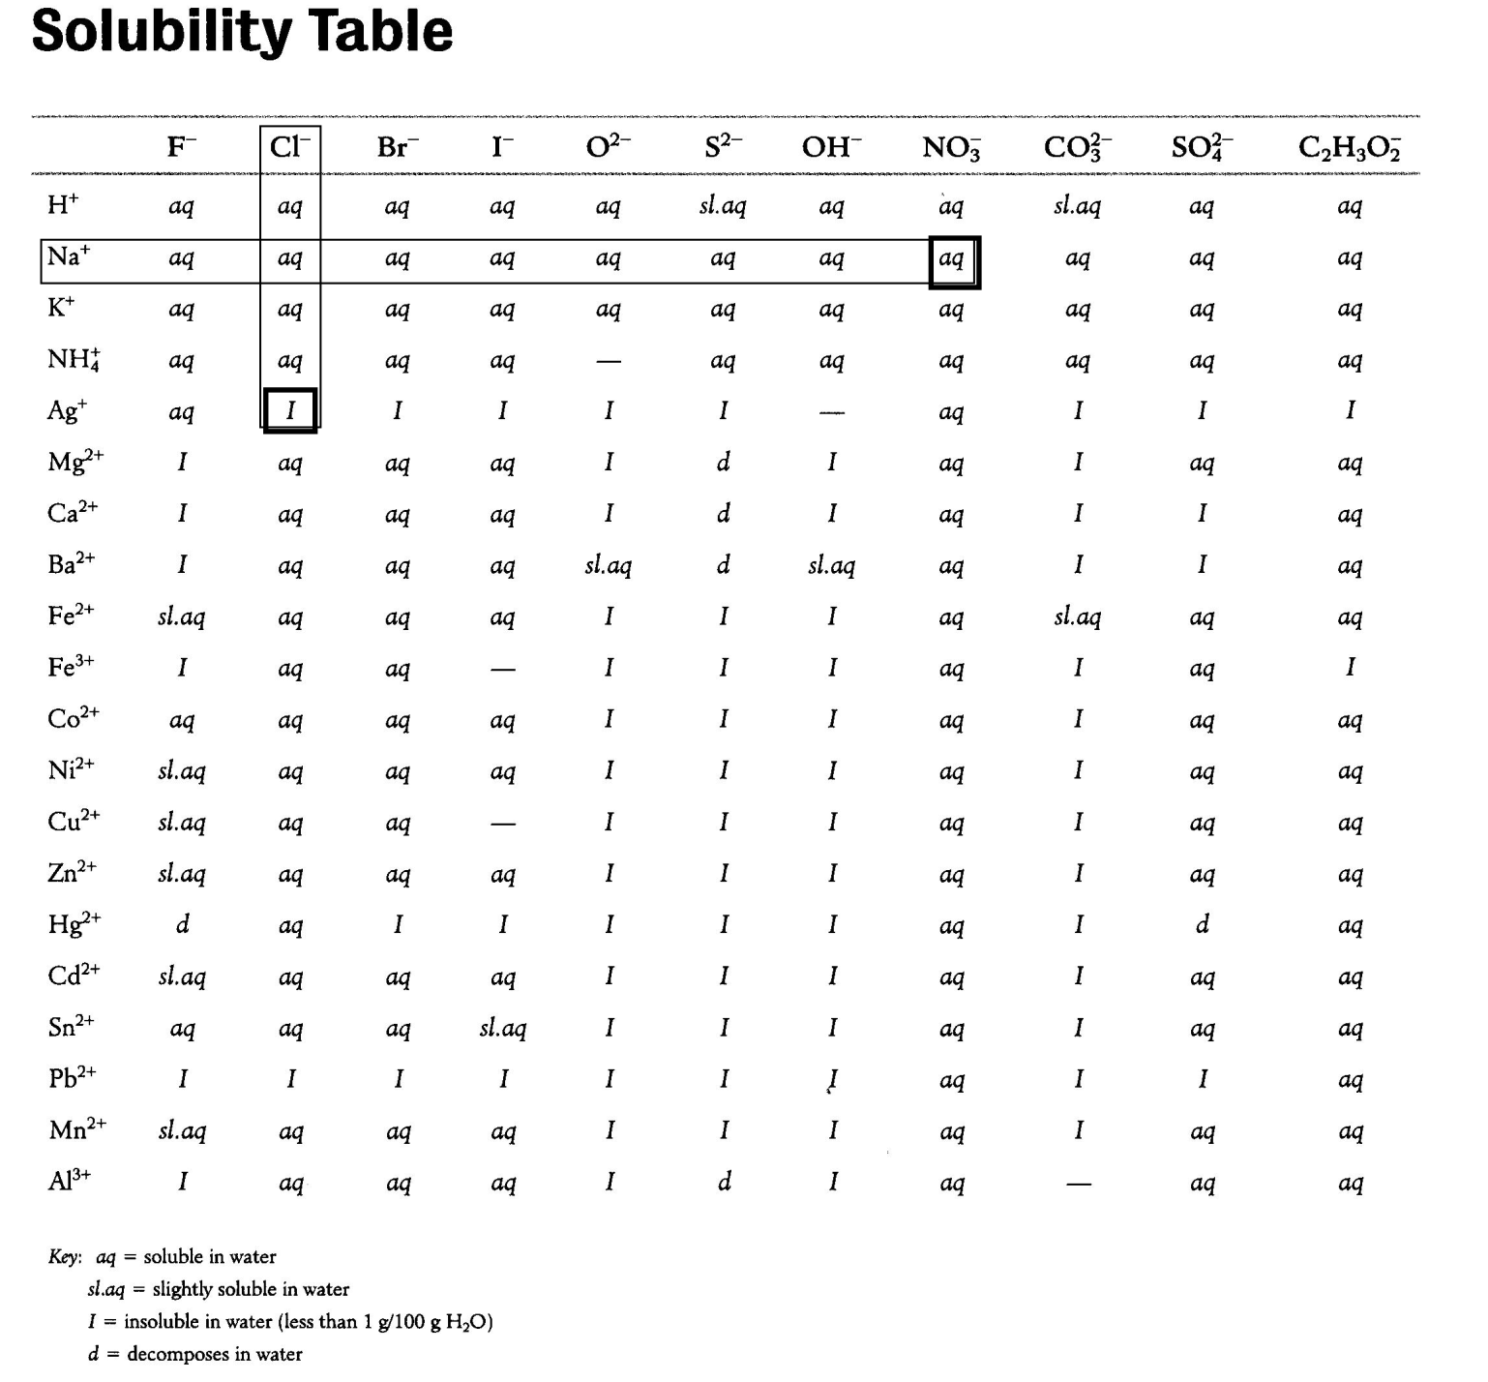

Types of chemical reactions

https://youtu.be/TX6BYceUSL0

Name: |  | Instructor: |  | Date:

Lab Report
Part 1
(16 marks)

Here are some short videos on chemical reaction experiments, please write and balance the equation based on the chemicals shown in each video

https://www.youtube.com/watch?v=TJYOxGHNTzg&feature=player_detailpage#t=0

https://www.youtube.com/watch?v=fnzEICgBNIo&feature=player_detailpage#t=0

https://www.youtube.com/watch?v=mi8mtVpfZoc&feature=player_detailpage#t=0

https://www.youtube.com/watch?v=0K3jhSn3jp8&feature=player_detailpage#t=0

Part 2
View each video and provide the answers in the spaces provided. (8 marks each)
- Play the video: https://www.youtube.com/watch?v=KmhD8BmEFIo
Evidence of reaction (use the terms precipitate formed or gas evolved, or heat released, or heat absorbed) shown in the video:
Word Equation:

Balanced Equation:

- Play the video: https://youtu.be/GXTDOTrPdzM
Expected evidence of reaction (use the terms precipitate formed or gas evolved, or heat released, or heat absorbed):
Word Equation:

Balanced Equation:

- Play the video: https://www.youtube.com/watch?v=0K3jhSn3jp8&feature=player_detailpage#t=0
Expected evidence of reaction (use the terms precipitate formed or gas evolved, or heat released, or heat absorbed):
Word Equation:

Balanced Equation:

- Play the video: https://www.youtube.com/watch?v=ZsGAy8UXbDQ
Expected evidence of reaction (use the terms precipitate formed or gas evolved, or heat released, or heat absorbed):
Word Equation:

Balanced Equation:

Please balance the equations below and complete the table (18 marks)

Equation  (to be balanced) |  | Expected Evidence of Reaction |  | Type of Reaction
CaCO₃ + HCl CaCl₂ + CO₂ + H₂O
NaOH + HCl NaCl + H₂O
CaCl₂ + NaH₂PO₄ Ca(H₂PO₄)₂ + NaCl
NH₄OH + H₂SO₄ (NH₄)₂SO₄ + H₂O
Na₂CO₃ + CaCl₂ NaCl + CaCO₃
FeCl₃ + NH₄OH Fe(OH)₃ + NH₄Cl
NaHCO₃ + HCl NaCl + CO₂ + H₂O
Zn + CuSO₄ ZnSO₄ + Cu
Fe + HCl FeCl₃ + H₂

Feedback (1mark/ea)
- What did you like the most about the lab?

- What could be improved in this lab?

When complete, save the lab with your name, the course and the lab number in the file name, ex. “First_LastName_CHEM1008_Lab4.docx”, and submit to Blackboard.

